Oxford City Council’s
Community Centres Strategy
2016-2020

Bringing communities together:
Skills, Health & Life

Executive Summary

Oxford City Council has decided to retain an extensive network of community centres across the city. They differ widely in their size, range of activities hosted and their physical condition. The publication of this strategy is designed to establish the foundations for the long term management of the network and the support structures provided by the Council. The centres represent collectively a substantial investment in community managed facilities and the Council’s central strategic objective is to support them to be well used and inclusive places. This helps to bring people together, to provide a focus for local communities and to contribute to the wider objectives of improving skills, reducing inequalities and creating strong and active communities. Our resources will be prioritised so as to meet these objectives as effectively as possible.

In developing this strategy the evidence from a needs assessment (included in section six) that was undertaken by SLC consultants has been of major importance, and there has been extensive consultation with a steering group made up of representatives from the voluntary sector, the Federation of Community Associations, councillors and senior council officers. The strategy identifies ways in which the Council will support the development of the community centre network and prioritise its resources to extend and improve the ways in which the centres can serve their communities. The city’s communities are diverse and constantly changing, and the pace of this change has increased. These contextual factors, and the fact that community centres increasingly also serve city wide communities of interest and identity, means that the way the centres are run needs to reflect these changes.

The strategy identifies eight priority themes, in two key action areas -
Improving Facilities and Sustainable Management:

Improving Facilities

- Establish Rose Hill Community Centre as a widely used and inclusive community hub.
- Draw up development plans for the Blackbird Leys and Barton Community Centres aimed at widening and improving the range of functions and activities which they offer, and securing effective community involvement in the management of these centres.
- Consider the feasibility study on the development of East Oxford Community Centre and work with the Reference Group and stakeholders to extend and improve the range of activities offered at the centre.
- Develop a prioritised maintenance plan for all centres with a five year time horizon.

Sustainable management

- Identify and consult on ways in which those centres that are currently managed by the City Council can be effectively managed in future on a long term and stable basis with strong community involvement.
- Review the current lease arrangements for each centre and seek to agree new long term arrangements.
- Support Associations in developing management skills and expertise and in recruiting volunteers to run the centres’ activities.
- Support Associations to recruit and retain trustees and manage their buildings.

1. Setting the scene - Why do we need a Community Centre Strategy?

The Council owns 18 community centres of which the majority are managed by Community Associations. These Associations are essential to the running of these centres and their work is greatly valued by the Council. Where Associations have found themselves in difficulties the Council has offered support and assistance and in a small number of cases has stepped in to take on the management. The Community Associations are voluntary groups formed by members of the public who want to improve the quality of life in their neighbourhood. They are registered charities accountable to the Charities Commission for meeting their declared charitable objectives.

The Associations have become increasingly burdened with complex health and safety and building management issues, leaving less time to develop new activities, promote their centres, or work with organisations such as health services. This strategy focusses on finding new ways of supporting Community Associations in the recruitment, training and retention of trustees and also in building management.

Many community centre buildings are old and require increasing levels of maintenance. Across the centres there is currently around £1.5 million of backlog maintenance. While there is a strategic policy commitment to invest in the centres, continued reduction of government grants has made it increasingly difficult to dedicate a substantial budget to this purpose. The strategy explains what changes we need to make to prevent further deterioration in the fabric of community centres and to support the valuable services they provide.

There is also a need to ensure that each centre has an appropriate legal agreement in place. Robust legal agreements for tenants are essential to ensure health and safety requirements are met, for Associations to obtain external funding and to give the public confidence that its assets are being managed in the best interests of the communities they serve.

The Council operates services across the whole city and has focussed its resources in areas where there are the highest levels of social deprivation. The Council is committed to tackling deprivation and inequalities by providing high quality community hubs offering a broad programme of activities. The main priority areas are Blackbird Leys, Barton and Rose Hill and this is reflected in the priorities set out above.

2. What does the strategy cover?
- Our plans for the city’s community centres
- How we will make community facilities more accessible
- Creating a sustainable management model
- Our approach to working with communities

3. Where does the strategy fit within the overall Council Corporate Plan?

The Corporate Plan is the Council’s key policy statement and this strategy supports the following areas of the Corporate Plan:

Strong, Active Communities

Community centres can deliver broad benefits that will help to create strong and active communities. They aim to provide activities for all ages, and to provide places where people can go to meet, attend courses and engage in social activities.

Community centres can only be the vibrant and active places that we are aiming for if they attract residents and users. By improving the centres we aim to encourage a wider range of people to use them, to increase usage, to encourage community cohesion, reduce health inequalities and to tackle issues such as the isolation of older people.

A Vibrant, Sustainable Economy

Oxford is a thriving city and is experiencing a rapid growth in population and employment. As the local economy develops and changes it is vital that the facilities that are available to the different communities across the UK are also developed to reflect those changes.

Cleaner, Greener Oxford

The Council is committed to minimizing the carbon created by its activities. The new community centre at Rose Hill has incorporated a range of low carbon technologies such as solar panels to generate energy. All the development work within the strategy will incorporate the best possible low carbon approach.

An Efficient, Effective Council

The Council is willing to invest in community facilities where there is a strong business case both in financial terms and outcomes. The operation of the community centres in the city is efficient and effective where there is robust governance of the centre, its legal status is clear and it is well maintained.

By agreeing new leases the Council will clarify the responsibilities of Community Associations and the Council’s undertakings. Having developed a mutually agreed set of criteria for the ‘effectiveness’ of a community centre in collaboration with community associations, the Council will continue to work with them to maintain that effectiveness. The Council will, through its directly-run community centres, lead by example.

4. The Oxford context

Demography

In common with many cities, there are major social inequalities in Oxford. The Index of Deprivation 2015 ranks Oxford 166 out of 326, which places the city just within the bottom half of the deprivation ranking for local authority areas in England.

People living in the least deprived areas of the city can expect to live around seven years longer than people living in the most deprived areas.

10 of Oxford’s 83 ‘Super Output Areas’ are amongst the 20% most deprived areas in England. These areas, which are located in the Leys, Littlemore, Rose Hill and Barton areas of the city, experience multiple levels of deprivation – with low skills, low incomes and poorer levels of health.

Around 23% of Oxford’s under 16s live in low-income households and child poverty is a key concern in eight neighbourhoods which feature among the 10% worst affected in England.
In 2013, Oxford’s 'usual resident population' was estimated to be 155,000. The City's population grew by 12% over the decade 2003-2013 and is projected to continue to grow rapidly, with the 2016 population already estimated at 160,000.
Oxford is a diverse city; in 2013, 28% of Oxford's residents had been born outside the UK and an estimated 4,000 short-term international migrants were living in the city. These factors, combined with large student numbers, create a significantly transient population and new and emerging communities make effectively communicating the availability of community facilities even more important.
Health

Oxford exhibits a range of health inequalities, with the headline challenges being:
- A majority of Oxford residents do not undertake sufficient regular physical exercise to maintain good health.
- Life expectancy is 7.7 years lower for men in the most deprived areas of Oxford compared to the least deprived areas
- The health cost of inactivity in Oxford has been estimated at £2.1 million per year.
- 17,855 people in the Oxford City GP locality are registered with depression
- Mental health issues among the older population are very often directly linked to isolation and loneliness.

Figure 1 - Index of Multiple Deprivation 2015
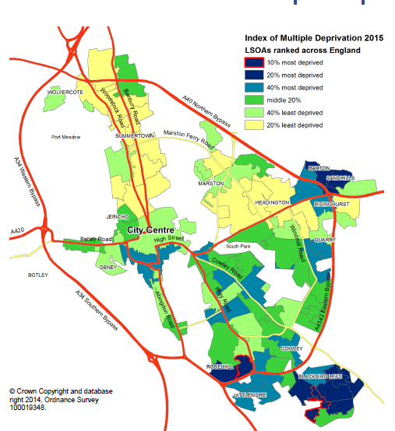
Super Output Areas ranked across England
Source: Department of Communities and Local Government

National context

These physical and mental health problems are placing significant burdens on public services and reduce our citizens’ quality of life. In addition, there have been cuts to health and to children’s services, with valuable resources such as children’s centres due to close in the near future.

To meet the challenges of these community needs, this strategy seeks to identify the ways in which community centres can best help to mobilise and channel a range of public, private and voluntary services.

5. Where we are now?

The Council’s ambition is to deliver world class services. The main challenges and opportunities for community centres are that:

  - The majority of Oxford’s population do not currently use or engage with their local community centre
  - Systems and procedures are not effectively shared, and centres are often competing for users
  - There is very limited performance data and no agreed measures of activity that would help to assess the centres’ effectiveness in meeting their objectives
  - The Council invests around £1million each year in community centres: how should the value for money from this investment be assessed?
  - Many of the buildings are of poor quality and there is a £1.5 million maintenance backlog
  - Many Associations struggle to recruit and retain trustees
  - The basis for occupation for many associations is uncertain. with some holding over on expired leases and others on outdated licences

However, our community centres successfully provide around 20,000 activity sessions each year demonstrating the potential and community benefits that could be attained by improving the current offer and developing the services on a longer term strategic basis.

The c£1 million that the Council invests each year on community centres consists of c£442,000 of direct costs (repairs and maintenance, waste and service charges and the support the Council commissions from Oxfordshire Community and Voluntary Action) and c£557,000 of “opportunity” costs derived from subsidised rental income and officer support costs.

As Council budgets reduce we need to look for new and more effective ways to run services and support community groups to best support the communities they serve. While all services differ, a good example is the Council’s capital investment of £14.5 million into leisure centres to transform their quality and range of services. This has led to usage increasing by 71% (mainly in the subsidised target groups such as older people and children) and revenue costs reducing by £2 million a year, there is no maintenance backlog and usage continues to increase. This challenge is to move the community centres onto a similar upwards trajectory.

6. How we have developed the strategy

A steering group was set up to support the development of this strategy. The group included the CEO of Oxfordshire Community and Voluntary Action, the Chair and
Deputy Chair of The Federation of Community Associations, the Board member for Communities & Culture, opposition members and senior officers.

Consultants were commissioned to undertake a geographic and demographic analysis of community centres using a Geographic Information System. They applied a 15 minute walk time catchment for each centre. The catchment is based on a judgement of how far Oxford residents can reasonably be expected to travel to access community centre provision. This has been overlain with ward boundaries, and the 2015 Index of Multiple Deprivation (IMD) ratings of each lower super output area (LSOA).

A methodology was devised to objectively assess each centre and its impact on the community in terms of providing accessible coverage in strategic areas of importance.

Community Centre ANALYSIS - DISTRIBUTION, CATCHMENT & IMPACT
1 | Barton Neighbourhood Centre | 15 | Regal Community Centre
2 | Blackbird Leys Community Centre | 16 | Risinghurst Community Centre
3 | Bullingdon Community Centre | 17 | Rose Hill Community Centre
4 | Cheney Community Centre | 18 | South Oxford Community Centre
5 | Cutteslowe Community Centre | 19 | Wood Farm Community Hall
6 | Donnington Community Centre | 20 | The Asian Cultural Centre
7 | East Oxford Community Centre | 21 | East Oxford Games Hall
8 | Florence Park Community Centre | 22 | West Oxford Community Centre
9 | Headington Community Centre | 23 | St Margaret’s Institute
10 | Jericho St Barnabas Community Centre | 24 | The Barn
11 | Jubilee 77 Community Centre | 25 | Barns Road Community Rooms
12 | Littlemore Community Centre | 26 | Mortimer Hall Marston
13 | North Oxford Community Centre | 27 | Littlemore Village Hall
14 | Northway Community Centre and Sports Centre (considered together for the purposes of this study) | 28 | St Luke’s

Key
 | Not owned by OCC |  | Owned by OCC
Table 1 – community centre key

The below insights map shows where the city’s community centres are in relation to areas of deprivation.
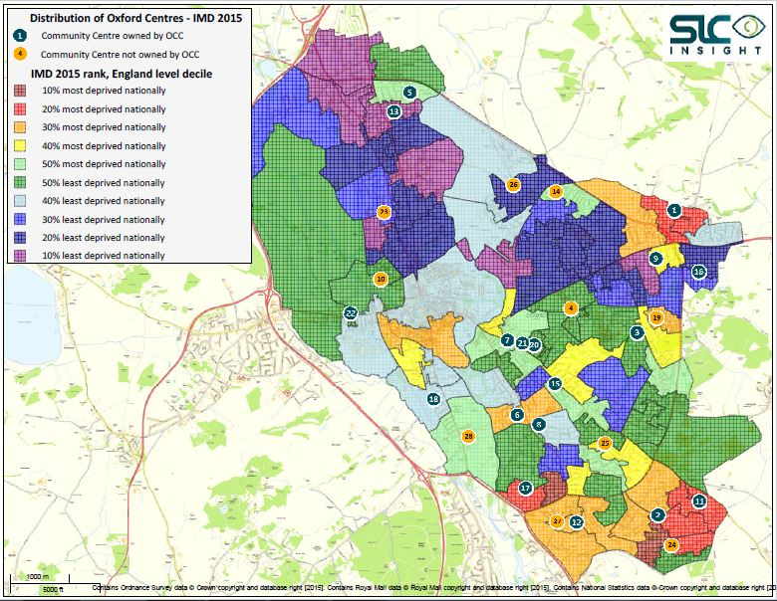 Figure 2 – location of community centres in relation to deprivation

Figure three shows the density of community centres using the 15 minute walk time. This map highlights the opportunity to combine the East Oxford Games Hall with East Oxford Community Centre to create an improved quality community hub which we will explore.

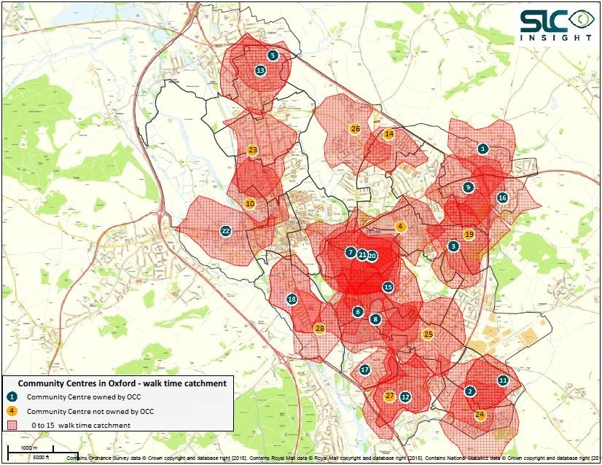
Figure 3 – community centre catchment areas

Predictably, Oxford’s city centre has a large number of facilities as there is a wide range of community and educational facilities. Figure 3 shows gaps in community facilities in parts of Blackbird Leys, Marston and Churchill. This does not mean that new facilities are required, as there is a good overall provision, but it does mean that planning decisions shall take this into account and that an increased effort is needed to ensure that people are aware of their local facilities.

Centres and Areas of Strategic Importance

There are a number of centres which, from the perspective of their location and catchment area, serve an area of strategic importance in terms of relative deprivation levels which would otherwise not fall within the catchment of any other centre. The facilities which exclusively serve significant areas of LSOAs within the 0%-20% most deprived nationally are shown below

Ref | Name | Reason
1 | Barton Neighbourhood Centre | Serves an area of Barton & Sandhills within 10%-20% most deprived nationally
2 | Blackbird Leys Community Centre | Serves an area of Northfield Brook within 10%-20% most deprived nationally
11 | Jubilee 77 Community Centre | Serves an area of Blackbird Leys within 10%-20% most deprived nationally.
14 | The Barn | Serves an area of Northfield Brook within 0%-10% most deprived nationally and an area of Blackbird Leys within 10%-20% most deprived nationally
17 | Rose Hill Community Centre | Serves an area of Rose Hill & Iffley within 10%-20% most deprived nationally
Table 2 - Centres of strategic importance

This evidence is combined with the Council’s priorities and local knowledge to create our plans.
7. Our plans

Objective One – our investment plans

The Council will place a high priority on the establishment of high quality and inclusive community hubs in the priority areas that have been identified, providing a range of public and voluntary services including health, advice and leisure activities.

The new Community Centre at Rose Hill provides an example of the type of integrated and multi-functional space that would be sought for these hubs. Development at Barton Neighbourhood Centre will be supported by developer contributions, and the regeneration plans for the centre of Blackbird Leys incorporate a new Community Centre as part of the reorganisation and renewal of the area.

Investment in other Centres will be assessed in relation to the objectives of this strategy to foster strong and active communities, and to provide access to resources and services that will improve skills, reduce inequalities and improve health. £670,000 has been allocated to support improvements at the East Oxford Community Centre. Any changes will be informed by thorough consultation to assess levels of support for different types of improvement plan.

A key factor in the prioritisation of future capital investment, alongside the social policy objectives identified above, will be evidence of good governance and the existence of a long term lease.

Having now established a basis for terms of a lease that provides a suitably long term with no rent we see no reason why new leases could not be rolled out to all centres speedily. We will provide support to associations who want to complete a new lease through OCVA and support to meet reasonable legal fees.

The Council’s annual repair and maintenance budget supports the day to day needs of the Centres, but larger sums for more substantial maintenance or improvement projects will require approval through the annual budget review process.

In some cases, as in Barton, developer contributions from CIL or Section 106 agreements will be available for potential allocation, and in others there may be opportunities to lever in external funding using a City Council allocation as a ‘match’ or ‘pump prime’.

Major renewal plans are in prospect for two community centres (North Oxford and Jericho) that are affected by planned redevelopment schemes, and for which significant City Council involvement is required.

Many other centres have been working on plans for improvements and modernisations and as part of this new strategy, it is proposed to establish within six months a full schedule of these plans and to work with the Associations concerned to establish priorities. Taken together, the cost of the plans which represent the aspirations of the community centres is substantially greater than the likely available budget over the next few years, making the identification and winning of external funding sources of great significance if they are to be realised.

Objective Two – improved management

While the condition of buildings and facilities is important, it is the people and the activities that make community centres places that people want to visit. They need to be inviting, well managed and easy to access.

Leases

The leases through which Trustees hold their centres need to brought up to date. In a number of cases, the contractual term of the lease has elapsed and the associations are “holding over” under the terms of that lease. Some centres do not have a lease, and are operating with a licence to occupy the building. This provides very few rights and no security of tenure. Leases not only enable the building occupier to have a clear relationship with the Council as landlord, they are also essential if Associations are to obtain external funding which will be increasingly important to improve facilities and develop premises.

The Council is taking two approaches in respect of the different current legal status of the Associations.

For those Associations who currently have a lease with continuity of tenure under the 1954 Landlord and Tenant Act we will undertake individual negotiations on that basis to agree how they can best meet the needs of their local communities. This applies to West Oxford, Bullingdon, Florence Park, Headington and Risinghurst.

All other Associations will be offered a new 25 year lease without an automatic right to renew at the end of the term. This is to protect the long term interests of the Council and its successors, but will be accompanied by assurances concerning the right to renewal if the Association’s and the Council’s objectives are being met.

When an Association is failing to meet its objectives the Council will work with the Association to support it to improve in order to minimise the risk of forfeiture.

Council managed centres

The Council’s preferred option is that robust, sustainable community organisations should manage the community centres. A report in 2014 commissioned from consultants found that there could be operational improvements and efficiencies to be gained by bringing all the Council run centres into a single body through a charitable trust. There may also be benefits from such a model for Association managed centres as they could choose to buy services such as caretaking, cleaning, ICT systems or bid writing from such a trust body. However, these potential benefits are not exclusive to a trust model and we will explore a number of options to see if there are ways to ensure that the centres that are currently managed by the Council can meet the needs of the communities they serve.

Volunteers

People volunteer for a variety of reasons. Some want to gain experience, some want to meet new people, to acquire new skills, or use volunteering as a way to get a new job or start a career. Others just want to give back to their community, to help a friend or promote a worthwhile activity. The Community Federation have asked for more support in attracting and developing volunteers for their Associations. This will be realised by placing increased focus on the work that the Council commissions from Oxfordshire Community and Voluntary Action to support volunteers. We have already responded by creating a Communities Officer post who works with volunteers and support Community Associations.

Service quality

The Council will introduce customer feedback cards at the centres it manages and undertake an annual survey with individuals who do not use the centres to find out what could be done to increase the attractiveness and usage of the centres.

We will undertake monthly quality audits of Council run centres and develop improvement plans. Quality will be also be checked by introducing an external quality assurance system. Centres that are managed by Community Associations will be encouraged and supported to implement a continuous improvement plan and we will undertake an annual health check at these centres. These continuous improvement plans will clearly vary between large facilities and the smaller community halls where a relatively light touch will be appropriate.

Objective Three – improved community access

The Council’s policy has been to place greater resource into working in communities with the greatest needs. There are Locality Officers in the priority areas (Blackbird Leys, Rose Hill, Barton, Littlemore, Northway, Wood Farm and Cutteslowe). Their role is to support the delivery of the priorities that have been agreed with local councillors for each area and to coordinate the Council’s resources within these areas to support Councillors and work with partners to resolve issues. The Localities Team also help to keep local people informed about the facilities that are available to them and to help community groups find suitable venues. The Locality Officers are based in community centres around for half of their working week with the objective of helping the centres to become the heart of the community. They will support staff working in the centres with community engagement and outreach.

The transient nature of Oxford’s population means that a large number of people will not be aware of what community spaces are available and others, for a range of reasons, will either not want to access them or feel that the community centre is not for them. The Council will take an active role in promoting the community offer and targeting promotions at underrepresented groups. One way this will be fulfilled is by having an improved website that promotes not only community hubs and community halls but also community rooms and sports pavilions.

The strategy recognises that some people now expect to be able to book services online. The Council will introduce an online booking and payment system at the centres it manages. This has the additional benefit of enabling usage data and will help us to market the centres. We will explore how the usage of the system can be extended to help people book community centres across the city.

This data and improved customer feedback also helps to inform what activities are provided and at what times.

8. Demonstrating the difference

We will develop a manageable number of measures that will help us to track the success of the strategy. The below are measures we will use in Council managed centres and in collaboration with the Community Associations we will seek to develop a mutually agreed set of measures for the centres managed by Associations. Where more data is needed to be able to set measures we will use the first year of the strategy establish the baseline.

Ref | Measure | 2016 | 2017 | 2020 target
CC1 | Usage of our community centres | Establish baseline | 20% increase | 20% increase
CC2 | Number of sessions in our community centres | c22,000 | 25,000 | 30,000
CC3 | Number of sessions targeting health improvement | Establish baseline | Increase by 5% | Increase by 5%
CC4 | Number of sessions supporting targeting improving skills | Establish baseline | Increase by 5% | Increase by 5%
CC5 | Income at Council managed centres | Establish baseline | Increase by 5% | Increase by 20%
CC6 | Social impact of our community centres |  | Establish baseline | Increase by 5%
CC7 | Revenue cost to the Council of community centres | £190k direct costs | Reduce by 10% | Reduce by 10%
CC8 | Number of volunteers in our community centres | Establish baseline | Increase by 5% | Increase by 5%
CC9 | Satisfaction levels | Establish baseline | >85% | >85%
Table 4 – measures

The final section of the strategy demonstrates how we will achieve the eight priorities.

Priority 1 –Rose Hill…an exemplar Community Hub
What do we want to achieve? | How are we going to do it? | Milestones | When by | Who | Resources
A well-used centre | Excellent promotion of the centre | Marketing plan implemented | Jan 2016 | General Manager / Commercial Manager | £6,000 year one  Then £2,000 per year
Inclusive usage | A diverse programme of activities | Quarterly programme reviews | 2016 to 2020 | General Manager | Officer time
Financially sustainable | Annual review of fees and charges linked to budgeting process | Review every September | Annually | General Manager | Officer time
High levels of satisfaction | A motivated and well trained team  Obtain feedback from 20 users every month  Regular facility audits  Implement a quality management system | Training plan implemented  Commence  In place  In place | Jan 2016  2016 onward  2016  2016 | General Manager  Duty Officer  Performance Manager  Performance Manager | £2,000  Officer time  Officer time  £1,000

Priority 2 –Improve Blackbird Leys & Barton Community Centres

What do we want to achieve? | How are we going to do it? | Milestones | When by | Who | Resources
BARTON
Improved health offering at Barton | Support the expansion of the GP surgery at the centre and improve the sports hall | Plan developed  Works complete | 2016  2019 | Assets Manager | £200,000 developer contribution
Improve the sense of arrival and flow of the building | Review previous schemes and develop an integrated and costed plan | Cost the scheme  Implement the scheme | Sept 2016  Dec 2017 | Assets Manager  General Manager | Explore funding options
BLACKBIRD LEYS
A new Community Hub | Develop as part of the district centre development | Develop brief for community hub  Appointment of Delivery Partner  Hub opens | 2017  2017  2020 | Partnership & Regeneration Manager  Assets Manager  Partnership & Regeneration Manager | The costs are still being developed and funding would need to be allocated  Officer time

Priority 3 – Improve East Oxford Community Centre

What do we want to achieve? | How are we going to do it? | Milestones | When by | Who | Resources
Develop an affordable scheme | Improve the centre which may include consolidating existing community facilities to promote energy efficiency and reduced operational costs | Feasibility study finalised  Progress project if viable | 2017  2018 | Head of Service | £670,000  Finance potentially raised by joining provision onto one site, external grants and through the Council’s capital programme
Increased usage and satisfaction | Representative community reference group  Increase satisfaction levels | Continue to develop the group  Measure satisfaction | 2016  Jan 2016 onwards | Head of Service / Asset Manager  Centre coordinator | Officer time  Officer time

Priority 4 –Prioritised maintenance

What do we want to achieve? | How are we going to do it? | Milestones | When by | Who | Resources
Tackle the maintenance backlog | Prioritise funds  Support Community Associations to obtain external funding so improvement opportunities can be combined with maintenance works | Develop schemes of work  Meet community associations to talk though opportunities | Once a lease is in place  Summer 2016 | Head of Service/ Asset Manager  Active Communities Manager | Part of the Council’s corporate maintenance plan  Officer time

Priority 5 – Sustainable, effective management

What do we want to achieve? | How are we going to do it? | Milestones | When by | Who | Resources
A sustainable, high quality delivery model for the centres the Council currently owns | Asses the financial viability differing management models and the scope of services that could be included | Complete feasibility report | Jan 2017 | Head of Service | £12,000  Officer time
Improved systems and demonstrating impact | Robust consistent operating systems in place for Council manage centres  Improved quality  Explore how we can demonstrate the social and economic value of Community Centres | New system in place  All Council managed community hubs quality assured  Methodology in place | Summer 2016  2017  2017 | Active Communities Manager  Performance Manager  Performance Manager / Community Federation | Officer time  £3,000  Officer time
A joined up community offer | Promote the community offer on the website  Review arrangements to support building management at centres operated by Community Associations | Improve web content for Council managed centre  All community spaces promoted on the same website  Reviews undertaken | Autumn 2016  2017  2016 then annually | Communities Support Officer  Communities Support Officer  Performance Manager | Officer time  Officer time  Officer time

Priority 6 - Appropriate lease arrangements

What do we want to achieve? | How are we going to do it? | Milestones |  | When by | Who |  | Resources
All centres have leases in place | Implement two lease types:  Protected lease – negotiate terms with Associations  An unprotected lease – standard terms with a breakage clause. | All centres on one of these lease | November 2017 |  |  | Head of Service |  | Officer time

Priority 7 –Volunteers

What do we want to achieve? | How are we going to do it? | Milestones | When by | Who | Resources
Increased numbers, representatives and quality of volunteers in community centres | Improve how opportunities are promoted  Increase the focus in the work the Council commissions OCVA to do to support volunteers  Improved training for volunteers  Develop a shared database of volunteers | Changes in place  Update the 2016/17 service agreement  As above  Audit | Spring 2016  May 2016  Summer 2016  Autumn 2016 | Active Communities Manager  Grants officer  OCVA  OCVA | Officer time  Commissioning budget of £43,000  As above  As above

Priority 8 - Trustee recruitment and development

What do we want to achieve? | How are we going to do it? | Milestones | When by | Who | Resources
More, better trained and more diverse trustees | Work with partner organisations to better coordinate the recruitment and training of trustees  Review and refocus the OCVA commission | Working partnership in place  Update the 2016/17 service agreement | Summer 2016  April 2016 | Communities  Manager  Communities  Manager | Officer time  Commissioning budget of £43,000

These are geographic areas used for statistical reporting www.ons.gov.uk
DOH: Public Health Observatories – Oxford Health Profile 2014 http://www.apho.org.uk/resource/view.aspx?RID=50215&SEARCH=oxford&SPEAR
Department of Health – Be active Be Healthy, 2006/07, measure: cost of inactivity
Oxfordshire Mind’s 2013 Community Mapping report
The Needs Analysis for Older People in Oxford.

